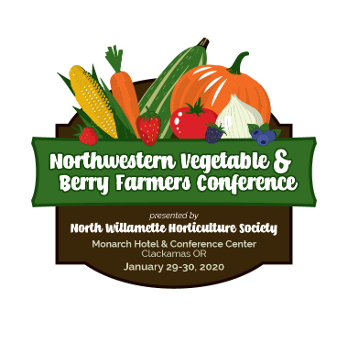
2020 Northwestern Vegetable & Berry Farmers Conference
Presented by the North Willamette Horticulture Society
January 29-30, 2020
The Monarch Hotel & Conference Center- Clackamas, OR

Registration

First & Last Name:Click or tap here to enter text.
Organization:Click or tap here to enter text.
Address:Click or tap here to enter text.
City:Click or tap here to enter text. State:Click or tap here to enter text. Zip:Click or tap here to enter text.
Work Phone: Click or tap here to enter text.
Email Address: Click or tap here to enter text.

General Membership / Registration Fee – includes registration, membership, and lunch for one person
Wednesday January 29 – Vegetable Focus: $55 $Click or tap here to enter text.
Thursday January 30 – Berry Focus: $55 $Click or tap here to enter text.
Wednesday January 29 & Thursday January 30: $100 $Click or tap here to enter text.
Additional Attendee: $55 $Click or tap here to enter text.
Additional Attendee First & Last Name: Click or tap here to enter text.
Sponsors:
Coffee or Wines & Cheese Social Sponsor: $50 $Click or tap here to enter text.
General Sponsor: $25 suggested donation $Click or tap here to enter text.
Contribution to NWREC: $250 $Click or tap here to enter text.
*Conference Sponsorship with one-page ad in the program: $500 $Click or tap here to enter text.
$2 Fee if paying by credit card: $Click or tap here to enter text.
TOTAL:$Click or tap here to enter text.
Payment Information:
Please remit payment by check to NWHS or by Credit Card ($2 Fee for all card transactions):
Name on Card: Click or tap here to enter text.
Card Number: Click or tap here to enter text. Expiration Date:Click or tap to enter a date.
CVV: Click or tap here to enter text.
Billing Address: Click or tap here to enter text.

Please mail to NWHS c/o NREC 15210 NE Miley Rd. Aurora, OR 97002
Registration also available online at www.nwhortsoc.com

*Ads should be emailed to nwhsevents@gmail.com by January 4, 2019

